Practice sums: 3.3.25
1. The TF of a UFB system is G(s) = K/s(s+5).
Draw the root locus.
2.
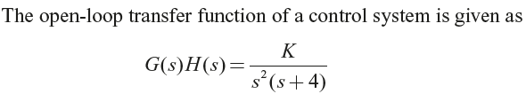
3.
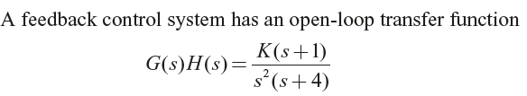
4.
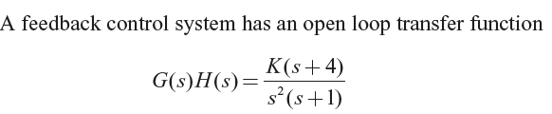

BODE:
1. Draw the bode plot for the system
G(s) = 5/s(s+1)(s+0.2)
Comment on the GM, PM of the system, ωgc & ωpc

